Operations & Help Desk Tools

SA GUI Trading Properties, Analysis & Design

David Jedeikin, June-July 2003

Version 0.2

- Information To Store & Display

It is expected that the trading properties data will be stored and read in using the server’s Properties service.

Since we are limited to key-value String pairs as far as what can be read in from the server, all needed data will be “packed” into the value part of a key-value pair; the different data elements (or “fields”) will be separated out using a non-typeable character (denoted here as “^”). The properties parser will “pack” and “unpack” this data into (and out of) the value part of a key-value pair.

All trading properties will reside within a specific properties category, to distinguish them from other properties (for different services) stored on the server. The category can be named something like [TradingProperties].

The following required and optional data will be stored:

- REQUIRED: Actual data value of the “value” (e.g. property “CAS Status” might have a data value of “1”); this is the raw data, not its display value.
- REQUIRED: Display value of the key (e.g. the property might be named “casStatus”, but onscreen we might want to display “CAS Status”)
- REQUIRED: Display value of the value (e.g. the actual data value might be “1” but we might want to display “Up” onscreen; see below for more info on display values)
- REQUIRED: Data type (this can be the fully-qualified class name such as java.lang.Integer, or a constant hard-mapped to this class in our code)
- Whether item should reference a value list (see “Dealing with value lists,” below)
- Legal value list values (see “Dealing with value lists,” below)

- Dealing With Value Lists

What if data and display values map to certain, fixed values that in turn displays in a certain, fixed manner? For instance, the property “casStatus” may always need to return either “1”, “2” or “3”. Declaring it an Integer data type isn't enough. We should have the ability to provide “legal values”. We also need the ability to map those values into fixed “display values”. Clearly, some sort of value list support is needed.

To solve this, value list values will themselves be stored as key-value pair properties. Properties that call for a value list will always reference the list as a query in the “display value” field. The value list's elements will each be stored individually.

For instance, here is a trading property:

CasStatus=1^CAS Status^casStatus.values.*^java.lang.Integer^@ValueList

The fields within the “value” are: actual value; key display value; display value (which instructs the parser to reference a value list); data type; and the fact that the property’s display value is a member of a value list.

The parser will therefore look up all properties beginning with casStatus.values. To continue this example, assume the following key-value pairs exist and will be read in:

casStatus.values.up=1^^Up
casStatus.values.down=2^^Down
casStatus.values.unreachable=3^^Unreachable

The parser will look up all key-value pairs starting with the String found in the property’s actual value. The GUI can be coded to return an error message if an illegal value is found (or somehow entered). Better still, when users are entering data, the GUI will “know” when a “value list”-type property is encountered, and can represent the property with a combobox or some other GUI widget that doesn’t allow users to enter anything other than a predefined legal value.

- Dealing With Tree Structures

Some properties will need to display as part of a hierarchical (i.e. tree) grouping. To do this, the keys for the tree values should be named hierarchically. The parser on the client-side will be responsible for building the tree (as well as “un-building” it to persist the individual key-value properties back to the server).

For instance, the root node of a tree grouping of properties might look like this:

key:
qrmStatus.tree

value:
23^^Sample Tree^I’m the root^java.lang.String

(in this case, the property is NOT part of a value list; its data value is 23; its display value is “I’m the root”; it’s a String; and the last field denotes it’s part of a tree. Since there’s no parent value, it is assumed this property is the root of the tree. If more than one property with no parent is found, the GUI should probably display an error of some kind)

A first-level node might look like this:

key:
qrmStatus.tree.detail1

value:
57^^I’m the first level^java.lang.String

The hierarchy here is determined by the key – in this case, this property will go under the “.tree” property.

A second-level node might look like this:

key:
qrmStatus.tree.detail1.detail2

value:
63^^I’m the second level^java.lang.String

For more information on how tree structures should be represented in the data model, see “Preliminary Design,” below.

- Preliminary Design

The parsing logic to read and write trading properties can be applied to any CBOEDirect service that needs to “pack” and “unpack” multiple fields of information in a key-value pair. Consequently, this mechanism can be generalized, and specific implementations built using the Factory pattern in HomeBuilder. The class hierarchy would be as follows:

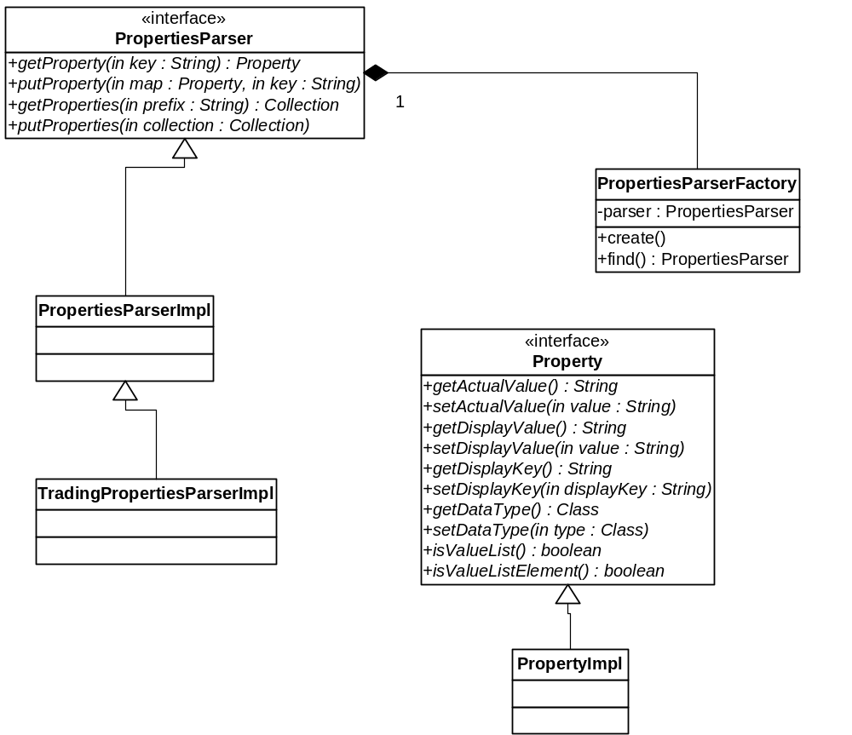

The Property interface defines the methods to get and set field information for a given property, as well as some other methods for working with value lists (see “Dealing With ValueLists,” above). It essentially represents the key-value pair as an object.

The methods in PropertiesParser (implemented in PropertiesParserImpl) do the following:

- public Property getProperty(String key)
Unpacks the fields contained in the value of a key-value pair, and returns these as a Property object. The property to return is specified by the key parameter.

Additional getters and setters may be created for additional fields (i.e. value list information) – these may be placed in a second interface for impls to implement.

NOTE: This method should throw Exceptions for properties not found.

- public void putProperty(String key, Property property)
Sends the property key-value back to the server to be persisted.

NOTE: This method should throw Exceptions if the persist fails.

- public Collection getProperties(String prefix)
Loads all properties matching a given prefix. The Collection returned will be a Collection of Propertys. See getProperty(), above, for more information on loading properties.

- public void putProperties(Collection collection)
Persists all tree-related data to the server. See putProperty(), above, for more information on persistence.

